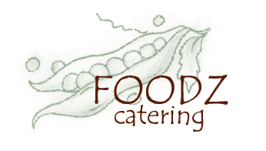

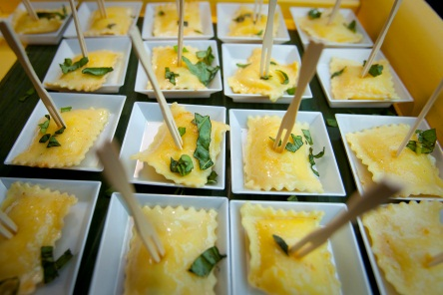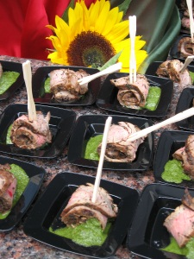

Passed Hors D’ Oeuvres

Lemon and Ricotta Ravioliettes
Topped with Sherry Walnut Basil Sauce

Fire Grilled Tender Flank Steak Bites
Garnished with a Sweet and Spicy Cilantro Pesto

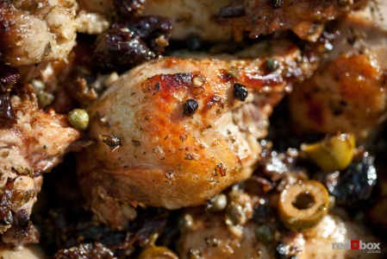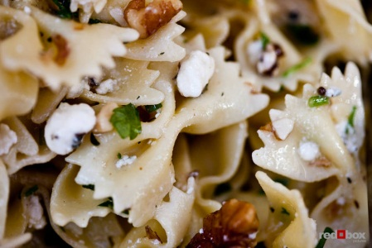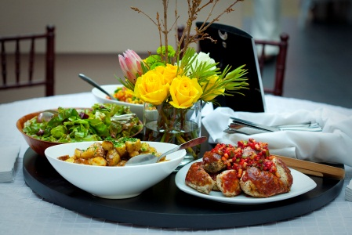

On Circular Buffet

Chicken Marbella
Juicy Chicken Breasts Marinated with Sicilian Green Olives, Prunes and Capers,
Roasted with Spanish Sherry, Oregano and Garlic

Gorgonzola Walnut Farfalle Pasta
Fresh Thyme and Farfalle Pasta with Sweet Roasted Garlic,
Crunchy Walnuts and Gorgonzola Cheese

Perfectly Roasted Seasonal Vegetable Antipasta
A Delightful Combination or Green Zucchini, Red Onions, Eggplant,
Yellow Squash, Red Peppers, Potatoes, and Mushrooms
Drizzled with Balsamic Vinaigrette

Caesar Salad with Garlic Croutons
Crisp Romaine Lettuce Tossed with House Made Lemony Caeser Dressing,
Toasty Garlic Croutons and Lavished with Parmesan

Locally Made Focaccia Bread from Essential Bakery

